SAMPLE 1
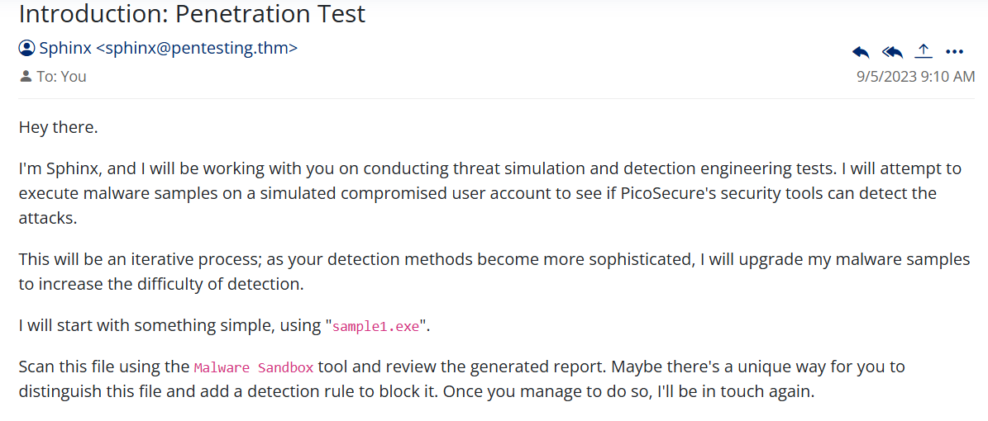
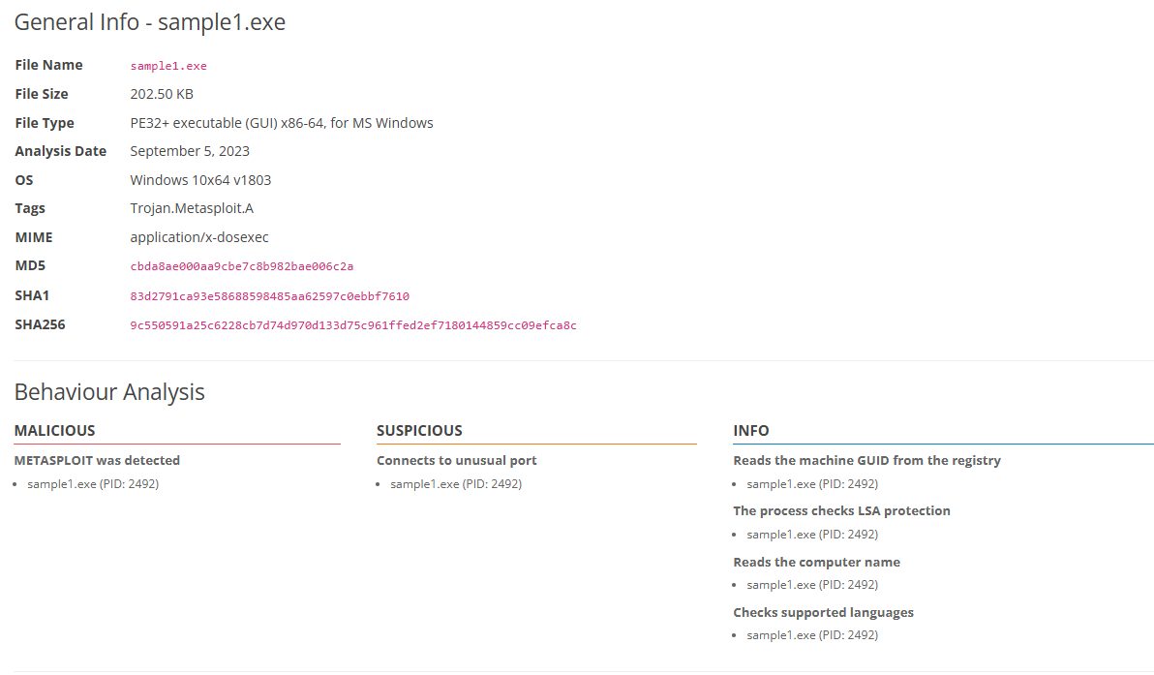

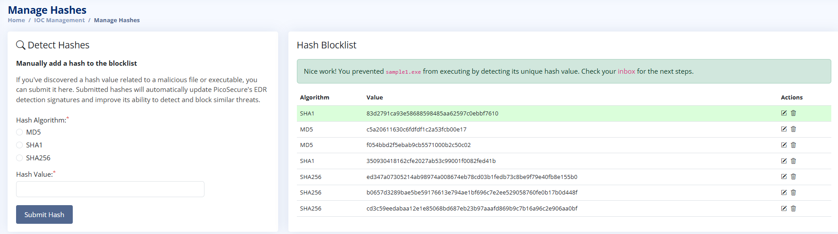
What I did: Hash values (trivial for the attacker to change)
Issue: Sphinx sent sample1.exe, a 202.5 KB Windows executable that the Malware Sandbox tagged as Trojan.Metasploit.A. The behaviour analysis flagged Metasploit as malicious and showed a connection to an unusual port.
Action: I copied the SHA1 hash from the sandbox report (83d2791ca93e58688598485aa62597c0ebbf7610) and added it to the Hash Blocklist in the IOC Management panel. The platform confirmed that sample1.exe was prevented from executing.
Why it matters: A hash identifies one exact file, so it is a very reliable indicator. But changing a single bit of the file produces a new hash, so the attacker can get around this block with almost no effort.

SAMPLE 2
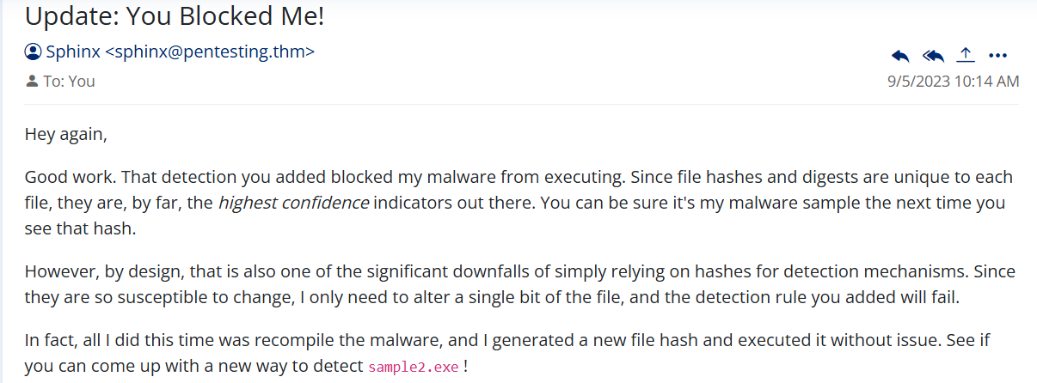
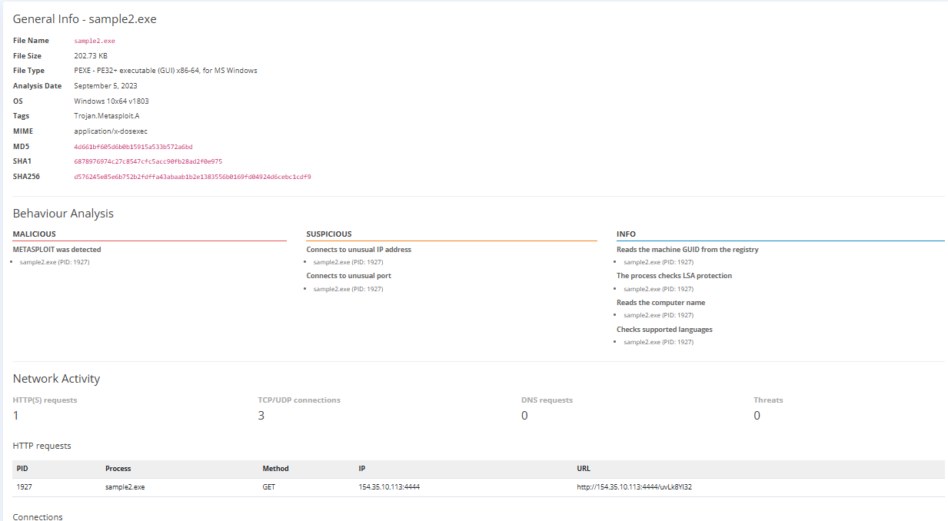

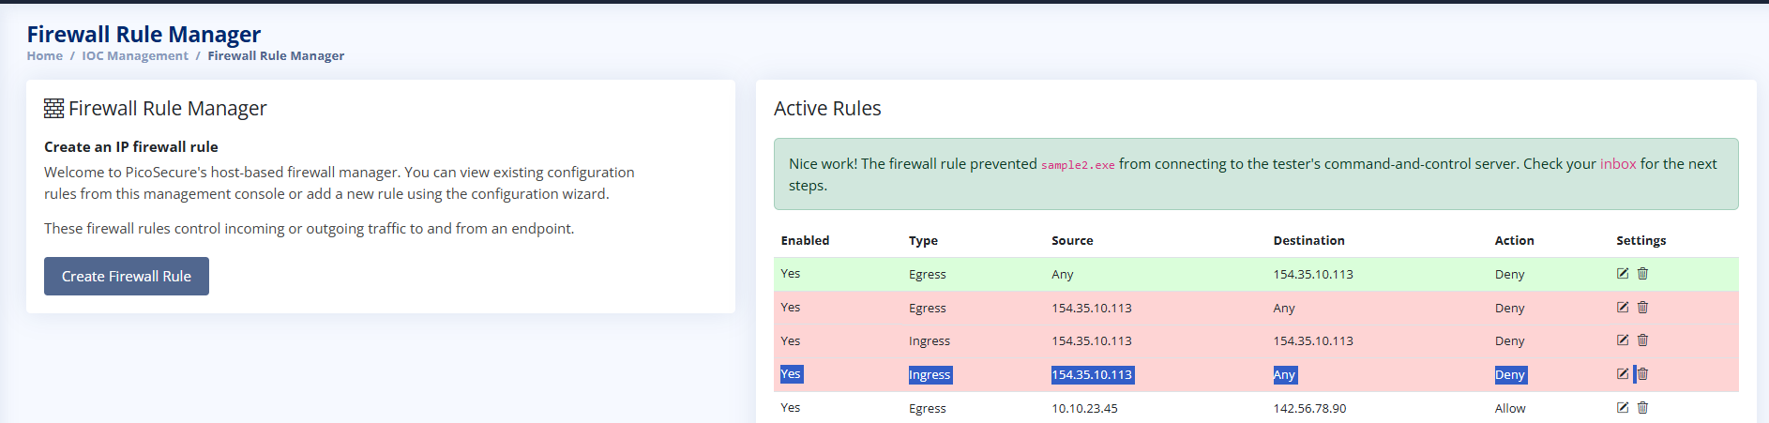
What I did: IP addresses (easy for the attacker to change)
Issue: Sphinx recompiled the malware, so sample2.exe had a new hash and bypassed my hash rule. The sandbox report showed it making an HTTP GET request to 154.35.10.113 on port 4444, which is its command-and-control (C2) server.
Action: I created a rule in the Firewall Rule Manager that denies egress (outgoing) traffic to 154.35.10.113. The platform confirmed that the rule stopped sample2.exe from connecting to the C2 server.
Why it matters: Blocking an IP is harder to avoid than blocking a hash, but a motivated attacker can move to a new public IP address, which is cheap and easy to get from a cloud provider.

SAMPLE 3
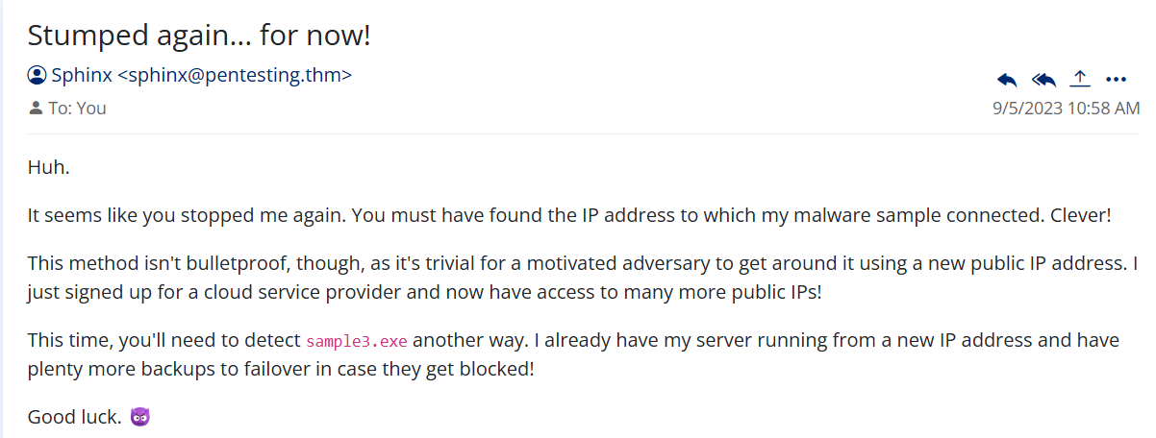
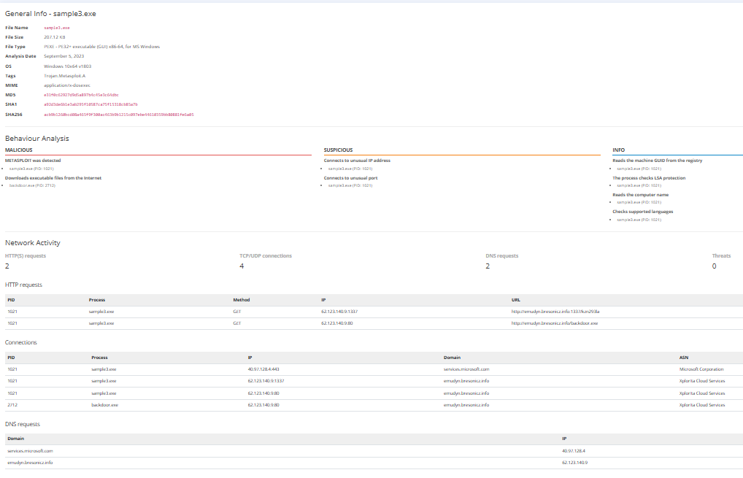
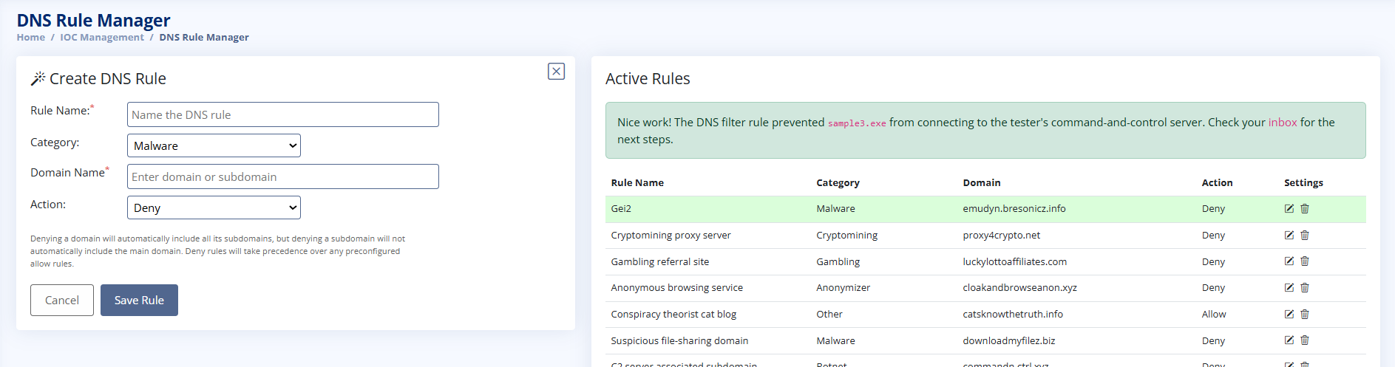
What I did: Domain names (simple for the attacker to change, but with some cost)
Issue: Sphinx moved to a new IP address, so my firewall rule no longer worked. The report for sample3.exe showed DNS requests and HTTP requests to the domain emudyn.bresonicz.info, and it also downloaded a second-stage file called backdoor.exe.
Action: I created a rule in the DNS Rule Manager with the category Malware and the action Deny for emudyn.bresonicz.info. Denying a domain also covers its subdomains. The platform confirmed that the DNS filter stopped sample3.exe from reaching the C2 server.
Why it matters: The attacker can change IPs freely, but the domain name stays the same. To get around this block he has to buy and register new domains and change his DNS records, which takes more time and money.

SAMPLE 4
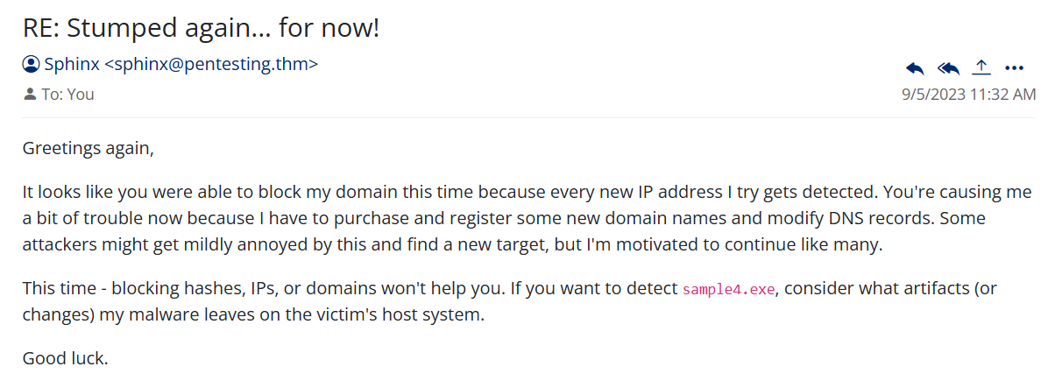

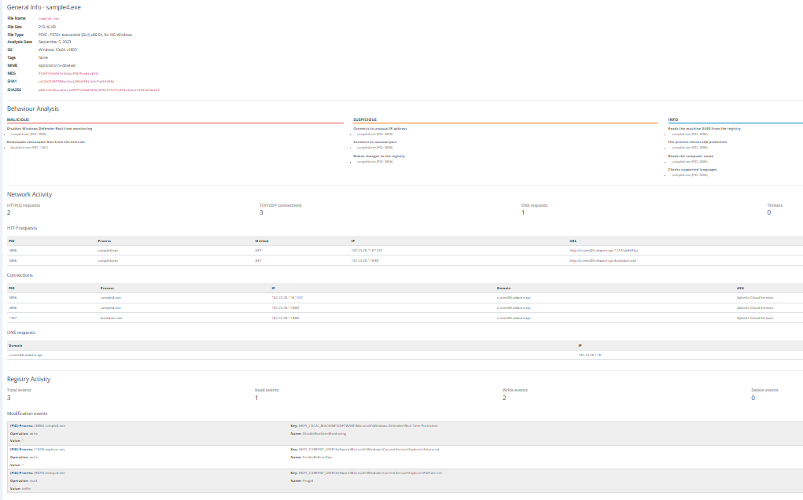
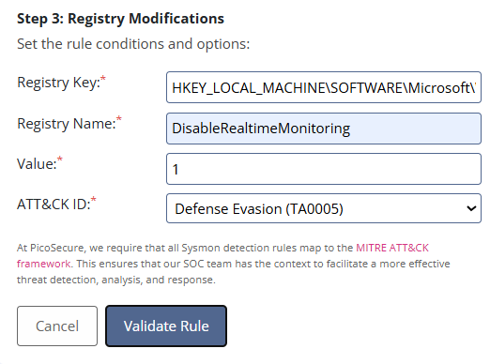
What I did: Host artifacts (annoying for the attacker to change)
Issue: Sphinx said that blocking hashes, IPs or domains would not help this time and told me to look at what the malware leaves on the victim host. The sandbox report for sample4.exe (Registry Activity section) showed it writing to the registry to disable Windows Defender real-time monitoring.
Action: I created a Sysmon registry-modification detection rule. The key is under HKEY_LOCAL_MACHINE\SOFTWARE\Microsoft\Windows Defender\Real-Time Protection, the registry name is DisableRealtimeMonitoring and the value is 1. I mapped it to the MITRE ATT&CK tactic Defense Evasion (TA0005).
Why it matters: I stopped looking at the attacker's infrastructure and started looking at what his malware changes on the victim machine. These traces are much harder to disguise or change.

SAMPLE 5

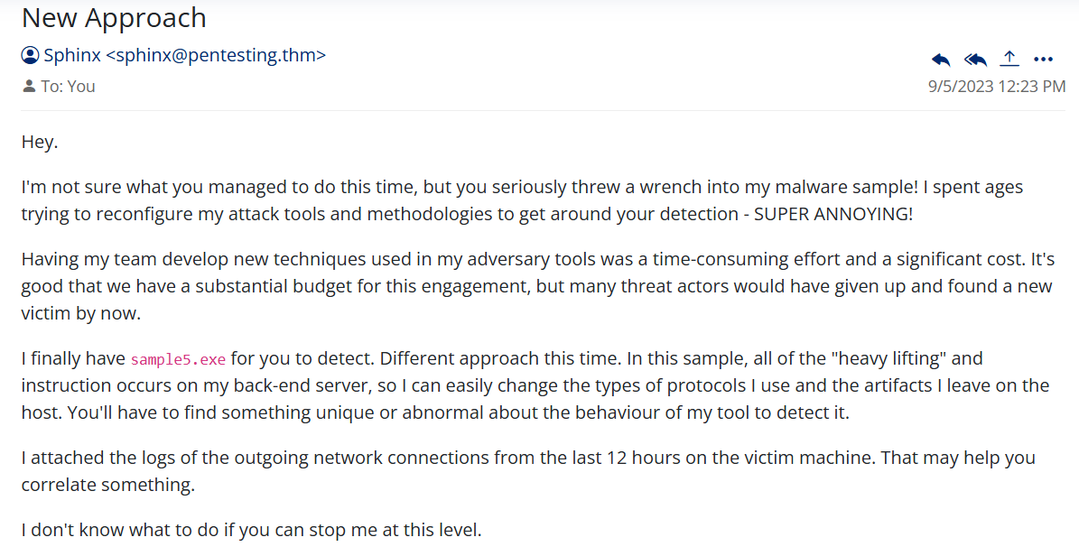

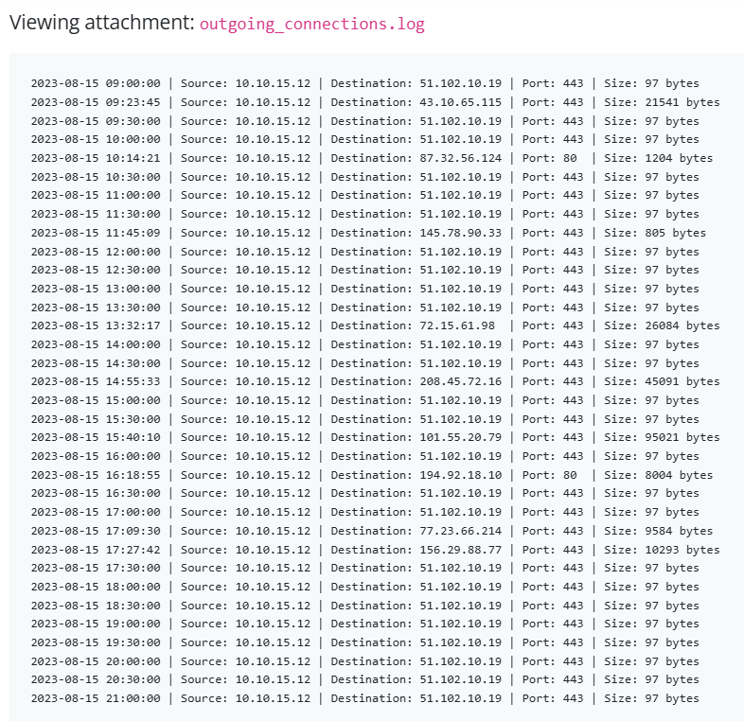
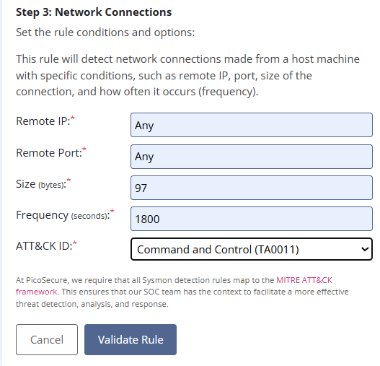
What I did: Tools and network behaviour (challenging for the attacker to change)
Issue: Sphinx switched to a tool where the heavy lifting happens on his back-end server, so there were no useful host artifacts to catch. He attached outgoing_connections.log from the infected machine (10.10.15.12). Most connections were varied and irregular, but one repeated: 51.102.10.19 on port 443, always 97 bytes, about every 30 minutes. This is beaconing, a regular check-in to a C2 server.
Action: I created a Sysmon network-connection rule with Remote IP set to Any, Remote Port set to Any, Size 97 bytes and Frequency 1800 seconds, mapped to the MITRE ATT&CK tactic Command and Control (TA0011). Sphinx's next email confirmed that sample5.exe was detected.
Why it matters: I detected the rhythm of the tool instead of its address. He can change IPs and domains easily, but to change this behaviour he has to build or learn a completely new tool, which is a significant cost.

SAMPLE 6

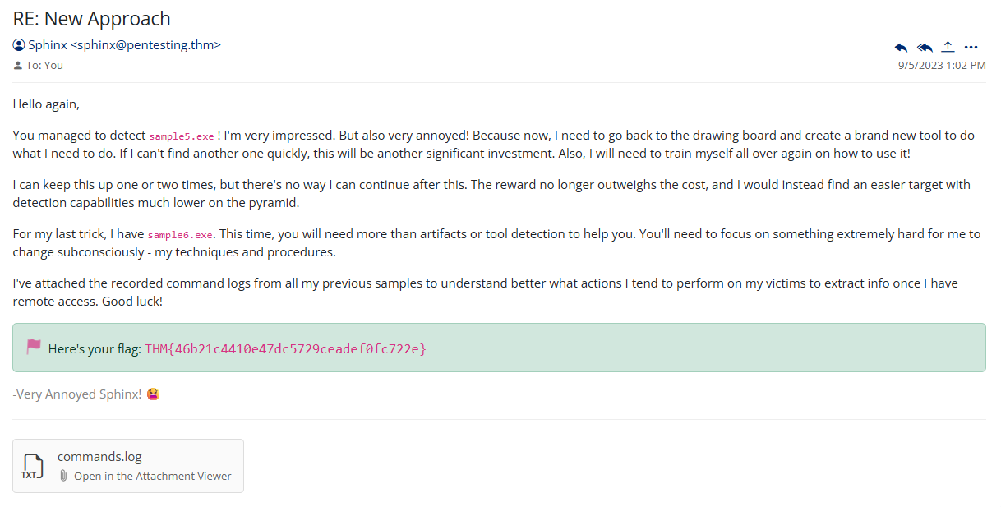

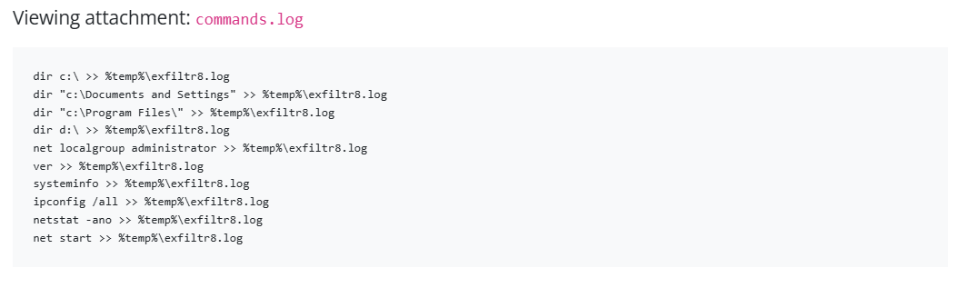
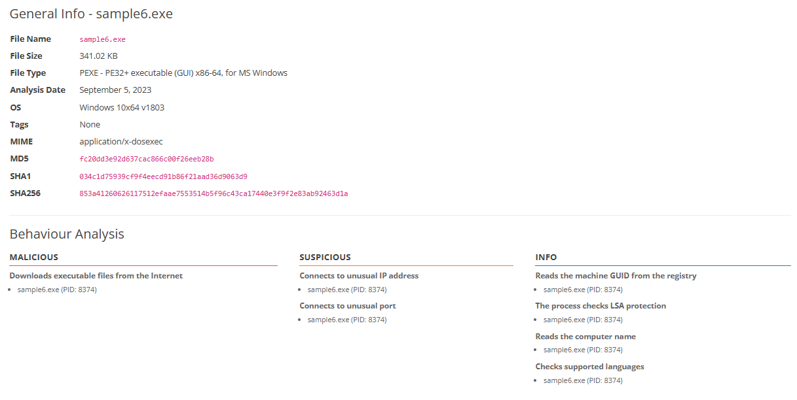
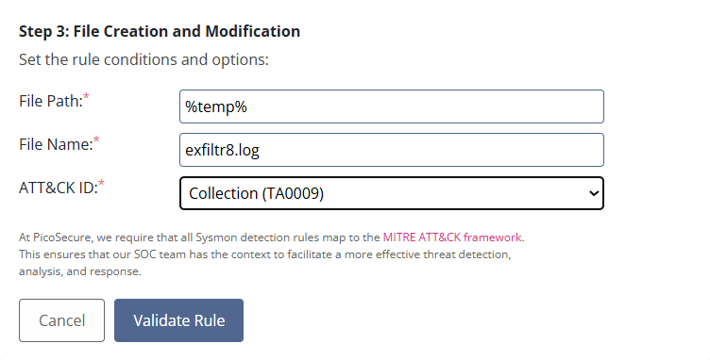
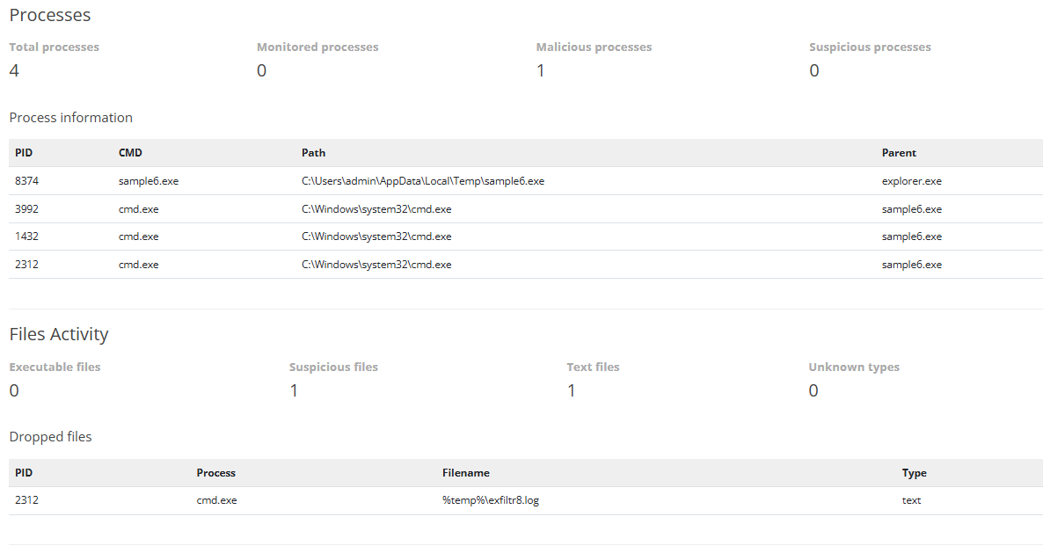
What I did: Tactics, techniques and procedures (TTPs) (tough for the attacker to change)
Issue: For the last sample, Sphinx gave me commands.log, which shows what his malware does after it gets access: discovery commands (dir, net localgroup administrator, ver, systeminfo, ipconfig /all, netstat -ano, net start) with every output redirected to %temp%\exfiltr8.log. The sandbox process tree for sample6.exe agrees with this. It runs from the user's Temp folder, starts from explorer.exe and spawns cmd.exe three times, and one of them drops exfiltr8.log.
Action: I created a Sysmon file creation and modification rule for the path %temp% and the file name exfiltr8.log, mapped to the MITRE ATT&CK tactic Collection (TA0009).
Why it matters: This targets how the attacker collects and stages information after gaining access, not a single tool or address. TTPs are the hardest thing for an attacker to change because they reflect his habits and methods. In a real environment I would also detect the command sequence and the parent-child process behaviour, because a fixed file name is easy to rename.

ACHIEVEMENTS
You systematically navigated the Sphinx detection platform, accessing multiple evidence sections in a logical sequence: hashes, sigma rules, firewall config, and supporting attachments (network and command logs). Each request returned HTTP 200 or 206, confirming successful resource retrieval.

Effective threat analysis requires methodical evidence gathering across multiple data sources. Your structured platform exploration demonstrates the investigative discipline required in SOC and detection engineering roles.

Flow:
- You retrieved hash indicators from the /hashes endpoint
- You reviewed Sigma detection rules from the /sigma section
- You examined firewall policies and network telemetry from attachments
- You collected command execution logs to cross-reference threat behavior

You explored both internal lab infrastructure (/sandbox, /firewall endpoints) and returned repeatedly to Sigma rules, suggesting you were correlating sandbox behavior with detection patterns. This multi-pass approach indicates iterative hypothesis testing and refinement.

Pyramid of Pain progression demands cross-linking IOCs with behavioral patterns. Your repeated Sigma access and sandbox correlation shows emerging capability in TTP-level detection design.

Flow:
- You accessed the sandbox analysis section alongside network and firewall data
- You revisited the Sigma rules section multiple times, suggesting pattern matching and validation
- You collected endpoint-specific and network-level evidence to build a complete threat picture

